I BOT – Std – 1
Chapter – 1
The Smart Machine.
I. Circle the Smart Machines:
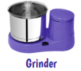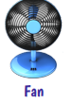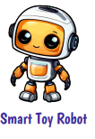
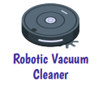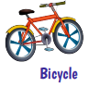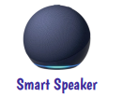
II. Fill in the missing letters:
1. S ___ A ___ T
2. C ___ M M U N I ___ A T E
3. ___ N T E R A C T I ___ E
4. L ___ S T ___ N
5. T ___ I N ___
III. Put or for the following:
1. A computer is a smart machine
2. Machines can think and respond on their own
3. AI means Artificial Intelligence
4. A desktop computer is portable
5. A computer makes learning interactive
IV. Choose the right option and fill in the dashes:
AI Machine Learning Smart Touch
1. A computer makes interactive.
2. ML is ____________________ learning.
3. A smart board is ____________________ sensitive.
4. ____________________ machines are devices with AI.
5. ____________________ means making machines think and act like humans.
V. Match the Following
 Portable Computer
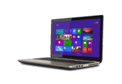 Pocket Computer
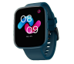 Voice Assistant
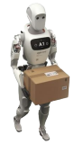 Robot at work
 Mops the floor
 Smart Wifi calling

VI. Answer in one or two words.
1. Which machine can listen, think and answer to our commands?
2. Which computer is big and is usually placed on a table?
3. Which computer is compact with touch screen interface?
4. Which is an interactive board?
5. What means teaching a computer learn by looking at examples?
Chapter - 2
Computer Fundamentals.
I. Rearrange the Jumbled Letters:
1. P U T N I
2. U T O P T U
3. O S M E U
4. Y E K O A B D R
5. D O I A U
II. Put or for the following:
1. Input refers to the result produced after processing.
2. Examples of output data include typing text and clicking a mouse.
3. CPU stands for Central Processing Unit.
4. Process refers to what the computer does with the input.
5. The work of the monitor and screen is to display text.

III. Circle the Input Units:
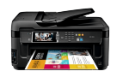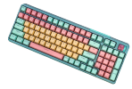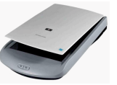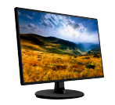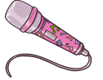
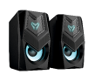

IV. Match the Following
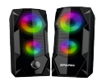 Brain of the computer
 Prints documents
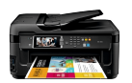 Clicking
 Plays audio
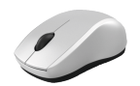 Displays text

V. Answer in One or Two words.
1. What is the full form of IPO?
2. What is Input?
3. Name the device with buttons and a scroll wheel.
4. What is also called the brain of the computer?
5. Name the parts of a computer.
................................., Monitor, ............................................, Mouse.

Chapter – 3
Getting Started with Scratch Junior
I. Fill in the Missing Letters.
1. H ___ M ___
2. H ___ L __
3. G ___ O W
4. S ___ R ___ N K
5. S ___ O W
II. Match the Following.
 Turn Right
 Start blocks
 Turn left
 Motion blocks
 Looks block
 Go Home

III. Pick the Right Option.
1. ______RATCH
2. ______AGE
3. ______RITE
4. ______RINK
5. ______UND
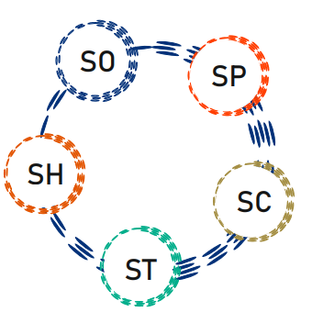
IV. Identify and Circle the following.
 Sprite  Backdrop
 Say Block
 Home Button
 Hop Block

V. Put or for the following:
1. The default sprite in ScratchJr is Tic.
2. Stage looks like a large black screen.
3. Block palette is located at the bottom of the stage.
4. Blue blocks controls sprite’s movement and direction.
5. A backdrop is the foreground image of blocks.
VI. Answer in One or Two words.
1. Name two sprites known to you.
2. Where are code blocks stored?
3. Which block type controls sprite movement and direction?
4. Which block type manages sprite's appearance?
5. What is the background image of the stage called?

Chapter – 4
Computers in our Daily Life
I. Fill in the Missing Letters.
1. A ___ P ___ A B E
2. W ___ B S ___ T E S
3. ___ R A ___
4. ___ O ___ O R
5. M ___ T R ___
II. Match the Following
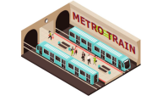 Patient Records
 Track Transactions
 Metro Prepaid Card
 Generate Reports
 Raise Bills

III. Put or for the following:
1. Children are not exposed to computers.
2. Teachers use computers to conduct interactive lessons.
3. A smart board is an interactive board.
4. We cannot track a flight using computers.
5. Shop keepers use computer to store patient information.
IV. Answer in One or Two words:
1. What role does a computer play in our daily lives?
2. Name any two medical machines controlled by computers.
3. Which device combines a projector and touch screen?
4. Who e-prescribes and monitor patient vitals using computers?
5. How can we get live updates on flight's current status?

Chapter – 5
Motion Blocks in ScratchJr
I. Fill in the Missing Letters:
1. D R ___ G
2. S ___ ___ P S
3. M ___ ___ E
4. R ___ T A T ___
5. T ___ R ___

II. Recognise the backdrops and name them correctly from the given options:
Farm Moon Park City Gym
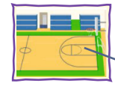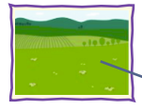


III. Put or for the following:
1. In ScratchJr, motion blocks are represented by yellow blocks.
2. Turn right block rotates sprite clockwise.
3. Go Home block moves sprite to its starting position.
4. To delete a sprite, just click on it and it will disappear from stage.
5. Hop block moves sprite up a specified number of steps and down again.
IV. Match the following
 Move Right
 Move Left
 Move down
 Hop
 Go Home
 Turn Left

V. Answer in One or Two words.
1. Which motion block moves sprite towards right?
2. Which motion block moves sprite downwards?
3. Which block rotates sprite in anti clockwise direction?
4. In ScratchJr, which blue block moves sprite upwards?
5. Which block moves sprite back to its home position?

Chapter – 6
Introduction to Windows 11.
I. Fill in the Missing Letters.
1. W ___ N D O ___ S
2. S ___ A R ___ H
3. W ___ D G ___ T S
4. W ___ N K ___ Y
5. E ___ ___ E
II. Put or for the following:
1. OS helps computer to work properly.
2. Widgets are found at the left corner of the taskbar.
3. Desktop consists of Icons and Taskbar.
4. System date and time is found the start menu.
5. To shut down the computer, click lock option.
III. Match the Following:
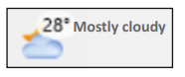 System Date and Time
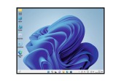 News
 Icons and Taskbar
 Deleted Files
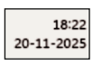 Find Apps
IV. Circle the Correct Keyboard Shortcut.
1. To open widgets
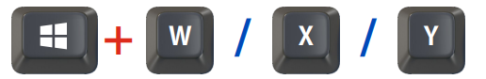
2. To access search button

3. To activate start button
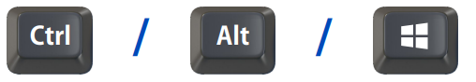

V. Number the Right Sequence to Start the Computer.
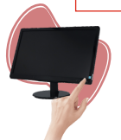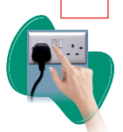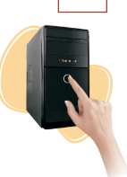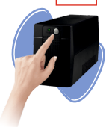

VI. Answer in One or Two words.
1. Which is the main screen that appears when you start your computer ?
2. Name the tiny pictures found on the desktop ?
3. Name the long flat bar located at the bottom of desktop ?
4. Which tool helps children to find their learning game on the computer ?
5. What are the three power button options?
Chapter – 7
Looks Blocks in ScratchJr.
I. Fill in the Missing Letters:
1. P ___ R P ___ E
2. C ___ D ___ N G
3. L ___ ___ K S
4. A ___ ___ E A R A N C E
5. C A ___ ___ O U T

II. Put or for the following:
1. Looks blocks are represented by yellow color.
2. Looks blocks are used to change sprite’s look.
3. Sprite can be deleted by long clicking on it and then tapping the red cross.
4. Grow block reduces character’s size.
5. Hide block hides the character from the stage.

III. Identify the given blocks and color them:
 Grow
 Shrink
 Hide
 Show
 Reset size
IV. Choose the correct answer:
Grow Say Show Shrink Hide
1. ______________ block makes the sprite appear with a speech callout.
2. ______________ block increases character’s size.
3. ______________ block reduces character’s size.
4. ______________ block hides the character.
5. ______________ block gets the character back on stage.
V. Answer the Following:
1. What is use of Looks blocks?
2. What happens when we long click on a sprite and tap red cross?
3. What happens when we click + icon from the left side of stage?
4. How can we move a sprite from its default position?
5. What happens when we click a block from the coding area?
Chapter – 8
Do’s and Don’ts of Computer
I. Fill in the Missing Letters:
1. S ___ S T E ___
2. M ___ U S E P ___ D
3. S ___ ___ E
4. S H ___ T D O W ___
5. C ___ B ___ E S
II. Choose the Correct Answer:
1. Keep a proper distance from the computer to protect your ______________ .
Eyes / Nose
2. Sit up straight with a comfortable posture to protect your back and ______________ .
Legs / Neck
3. If you are working continuously on the system, look away from the screen once in a while to give ______________ to your eyes.
Stress / Rest
4. Press keys ______________ .
Gently / Hard
5. Use computers only when a teacher is ______________ .
Absent / Present

III. Put or for the following:
1. A student is eating near the system.
2. A student is pressing the keyboard very gently.
3. A student is using the computer with wet hands.
4. A student is entering the lab with shoes.
5. A student is shutting down the computer after use.

IV. Match the Following:
 Sit straight
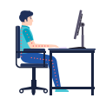 Shut down
 Don't pull wires
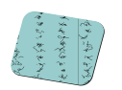 Don’t bang keyboard
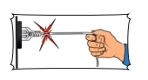 Better mouse control
V. Answer in One or Two words:
1. Whom should you ask for help if you have any problem with the computer?
2. Can we use wet hands to touch any computer part?
3. How should you press the keyboard keys?
4. What will you use for better mouse control?
5. What should we do after using the computer?

